 **February Special**

**Offers & News**

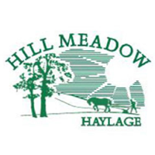

Hill Meadow Haylage 20kg Bale

£1.50 Off

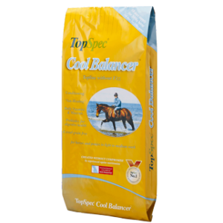

Top Spec Cool Balancer

Half Price during February

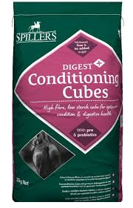

Spillers Conditioning Fibre & Cubes

£1.00 Off

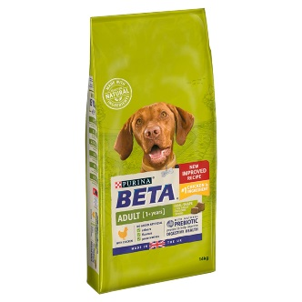

BETA Adult Chicken & Puppy 14kg Bags £5.00 Off

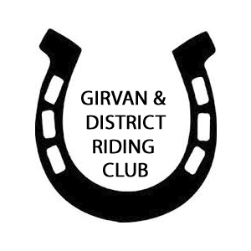

Table Top Sale

on

Saturday 21st March

at

Merkland Farm, Kirkoswald.

Book your table early @ clubentries.co.uk

Or call 0749634435 for more information